Individual Healthcare Plan for Allergy
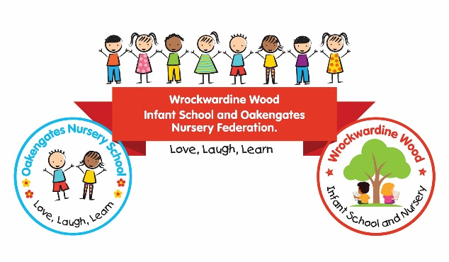 | Current photo
Name
Date of birth
Class
Emergency contact 1
Name:
Relationship to Child:
Telephone Number:
Emergency contact 2
Name:
Relationship to Child:
Telephone Number:
Allergy
What allergy or allergies does your child have?
What are your child’s known allergens/triggers?
Please list anything known to cause an allergic reaction, for example particular foods, medicines, insect stings, latex or other substances.
What signs or symptoms does your child experience when they have an allergic reaction?
Is your child able to recognise when they are having an allergic reaction and tell an adult that they need help? | ☐Yes  ☐No  ☐Sometimes
Please provide any further information that would help staff recognise when your child may be having an allergic reaction:
How is the allergy managed?
Does your child have an Allergy Action Plan or other care plan provided by a healthcare professional? | ☐ Yes – please provide a current copy  ☐ No
Has your child been prescribed medication for their allergy? | ☐ Yes  ☐ No
Has your child been prescribed an adrenaline auto-injector (AAI), such as an EpiPen or Jext? | ☐ Yes  ☐ No
If yes, please provide details:

What practical measures are normally taken to help your child avoid their allergen(s)?
For example, avoiding particular foods, checking ingredients or labels, preventing cross-contact, or avoiding particular substances or situations.

How much responsibility is your child currently able to take for managing their allergy? For example, can they recognise foods or substances they must avoid, ask an adult before eating something, recognise symptoms or know when to ask for help?

Impact on Education:
What could happen if your child’s allergy is not managed appropriately?
Please include the potential severity of an allergic reaction.
Does your child’s allergy affect their learning, attendance or ability to take part in school/nursery activities? | ☐ No  ☐ Yes
If yes, please give details:

Does your child’s allergy affect their emotional wellbeing?  For example, do they experience worry or anxiety about food, eating, having an allergic reaction or joining in with activities? | ☐ No  ☐ Yes
If yes, please give details:

Does your child have any special educational needs or additional needs that may affect their ability to understand, communicate or manage their allergy? | ☐ No  ☐ Yes
If yes, please give details:

Arrangements for support
To be agreed with parents/carers and completed by school/nursery
What specific support or adaptations will be put in place for this child?
How will we reduce the risk of the child coming into contact with their known allergen(s)?
What arrangements are required at meal and snack times?
Include any arrangements relating to food preparation, checking ingredients, avoiding cross-contact, supervision or other necessary precautions.
Are any arrangements required to support the child’s learning following allergy-related absence or missed learning? | ☐ No  ☐ Yes
If yes, details of support:

Visits and trips:
- Are any additional arrangements required to enable the child to participate safely in educational visits, trips, sporting activities, clubs or activities outside the normal timetable? | - ☐ No  ☐ Yes
- If yes, please give details:

- Is an individual risk assessment required for visits or particular activities? | - ☐ No  ☐ Yes
- If yes, the risk assessment should consider, where relevant:

- access to the child’s medication;
- food, snacks and meal arrangements;
- potential exposure to known allergens;
- travel arrangements;
- staff awareness and supervision;
- access to emergency medical assistance; and
- any other child-specific arrangements.

Emergency response

Does the child have an Allergy Action Plan issued by a healthcare professional?  If an Allergy Action Plan is in place, staff must follow the emergency instructions contained within the plan. | ☐ Yes – a current copy is attached to this IHCP  ☐ No
What signs or symptoms may indicate that the child is experiencing a serious allergic reaction?

What action should staff take in an emergency?

Emergency medication
Medication prescribed:
Where the child’s emergency medication is kept:
Location of the school/nursery’s spare adrenaline auto-injector(s), where applicable:
IHCP discussed and created with parents: | Date
Issued by: | Date:
Next planned review: | Date:
Staff who need to be aware of this plan:

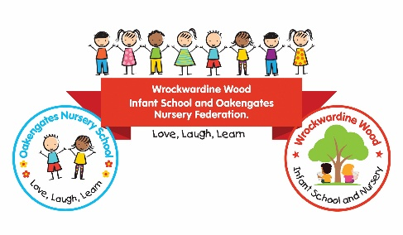 | Individual Healthcare Plan for Allergy  Annex A: Medication needed while in School/Nursery
Name:
Date of Birth:
Class:
Non-prescription medication
Does your child require any non-prescription medication to manage their allergy while at school/nursery? For example, an oral antihistamine. ☐ No ☐ Yes
If yes, please provide the following information:
Name of medication:
Dose:
When should the medication be given?
Please include the symptoms or circumstances that would indicate that the medication is required.
Is this emergency medication? ☐ Yes ☐ No
Where should the medication be stored in school/nursery?
How quickly does your child need access to this medication?
Parental consent:
Do you give consent for school/nursery staff to administer this medication to your child in accordance with this Individual Healthcare Plan and any associated Allergy Action Plan?  ☐ Yes  ☐ No | Parent Name:
 | Parent/Carer Signature
 | Date:
Prescription medication
Has your child been prescribed any medication by a healthcare professional to manage their allergy? For example, an adrenaline auto-injector (AAI), such as an EpiPen or Jext, or prescribed antihistamine.
☐ No
☐ Yes
If yes, please provide the following information:
Name of medication:
Dose and Strength:
When should the medication be given?
Please include the symptoms or circumstances that would indicate that the medication is required.

How should the medication be given?
Is this emergency medication? ☐ Yes ☐ No
Where should the medication be stored in school/nursery?
How quickly does your child need access to this medication?
Prescribed by and Date

Parental consent to administer prescribed medicine:

Do you give consent for school/nursery staff to administer this prescribed allergy medication in accordance with this Individual Healthcare Plan and any associated Allergy Action Plan?  ☐ Yes  ☐ No | Parent Name:
 | Parent/Carer Signature
 | Date:
Parental consent: Use of “spare” adrenaline devices:
If your child is at risk of anaphylaxis, do you give consent for the school/nursery’s spare adrenaline auto-injector to be administered to your child in an emergency, where appropriate and in accordance with their Individual Healthcare Plan/Allergy Action Plan?  ☐ Yes  ☐ No  ☐ Not applicable | Parent Name:
 | Parent/Carer Signature
 | Date:

Individual Healthcare Plan for Allergy
Annex B: Care or Action Plans issued by healthcare professionals
Name:

Action and Care Plans in Place
Please tick to all that apply and attach any Action Plan to the IHCP for use in an emergency.
Allergy Action Plan
Asthma Action Plan
Other Care Plan
Please name:
Plan/s Issued by:

Role/Service

Date issued

Review Date
if applicable

